*The best way to have a good idea is to have a lot of ideas. –*

**Dr. Linus Pauling**

**Linus Pauling Middle School**

**1111 NW Cleveland Avenue**

**Corvallis, OR 97330-2063**

**Office Hours: 8:00 a.m. – 4:00 p.m.**

**Alicia Ward-Satey, Principal**

**Greg Hyde, Assistant Principal**

**541-757-5961**

Linus Pauling Pride

*Parent Newsletter*

**April/May 2018 Linus Pauling Middle School Vol. 13 No. 5 Corvallis, Oregon**

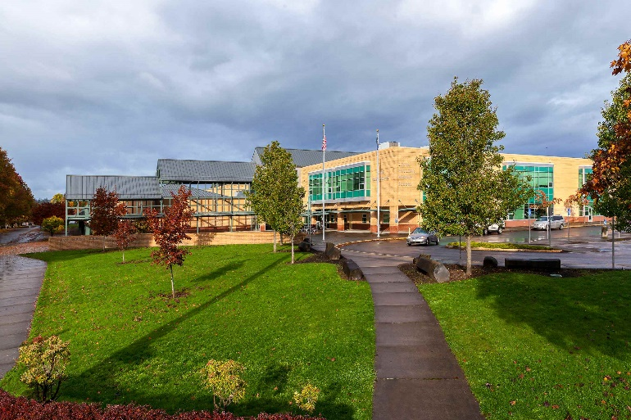

**Linus Pauling Families and Community,**

**Greetings!!!**

**During the month of April, I am especially excited about the many different projects and opportunities that students are participating in throughout the building. Mock Congress, a dual immersion art project, a fun STEM project in 7th grade science and of course a robust track and field team as well as our music classes getting ready for competitions are all examples of the many things happening at LP. It is fun to see the enthusiasm and engagement in the students.**

**As we head toward the end of the year, it is important that we continue to teach our students our behavioral as well as academic expectations. As I work closely with Kelsey Hibbert, Dean of Students, and the other staff in the support room around student behavior, I am concerned about the amount of conflict and unwanted drama that happens with students involved in social media. A couple of weeks ago, Kelsey shared an article with me from Psychology Today that I hope you find helpful as you**

**help your student navigate the world of social media and middle school.**

**There were a few points that I felt were especially pertinent to the experience of students at Linus Pauling. First, the fact that student’s brains are not yet at a stage of development that allows them to “manage the distraction nor the temptation” that comes with social media. At LP we have seen students from all walks of life struggle with knowing how to moderate and monitor their social media usage. Impulsivity and the inability at times to think about the consequences of their actions can lead to undesirable outcomes. Secondly, the fact that social media is “an addictive form of screen entertainment” is a reality for some students that we need to acknowledge.**

**Middle school is a key time to set students on a positive path for success in the future. Helping students to make healthy choices about technology is one of those choices that will help them be successful. Here is the link to the article, *Why Social Media is Not Smart for Middle School Kids***

[**https://www.psychologytoday.com/us/blog/mental-wealth/201703/why-social-media-is-not-smart-middle-school-kids**](https://www.psychologytoday.com/us/blog/mental-wealth/201703/why-social-media-is-not-smart-middle-school-kids)

**It is an honor to work at a vibrant, dynamic school like Linus Pauling and to see the growth of students from the time they join us in 6th grade to the time that they leave us in 8th grade. I am looking forward to a positive end to a wonderful year.**

**Sincerely,**

**Alicia Ward-Satey, Principal**



**Volunteers needed!  Please read on!**

**Oregon Middle School Meet of Champions 2018: May 24, 2018**

**Volunteer and Official Information Form**

The Oregon Middle School Meet of Champions is one of the biggest and certainly the most competitive middle school track and field meet in Oregon.  Last year, 600 athletes from 150 teams contested 28 track and field events.  Now in its 8th year, Linus Pauling MS will again host the meet at Spartan Stadium at Corvallis HS.  The meet lasts from approximately 9:30-4:30, but most volunteer positions last about two hours.

**General Volunteers**

There are many jobs available for someone with little experience, from selling shirts to welcoming athletes to the stadium.  For these jobs, you need to be comfortable working with people, but we can easily train you on the details.

If you are able to work at the meet, please use the link below to officially sign up for your desired job/time slot.

[2018 Oregon MOC Signup](http://signup.com/go/rESkBe)

 If you have questions, email meet director Coulter Rose at

[lpmstrack@gmail.com](mailto:lpmstrack@gmail.com)

**Track & Field Meet Schedule**

|  |  |  |  |  |  |  |  |
| --- | --- | --- | --- | --- | --- | --- | --- |
| Thu, Apr 12 | Patton M.S. | Patton M.S., McMinnville |  | 4:00 PM |  |  | |
| Thu, Apr 26 | MVCC @ Cheldelin | Cheldelin Middle School, Corvallis |  | 4:00 PM |  |  | |
| Fri, Apr 27 | 800m Middle School Challenge - OSU High Performance | Whyte Track & Field Center, Corvallis |  |  |  |  | |
| Tue, May 1 | MVCC @ Talmadge | Panther Stadium (Central HS), Independence |  | 4:00 PM |  |  | |
| Thu, May 10 | MVCC @ Philomath Linus Pauling, LaCreole | Philomath HS, Philomath |  |  |  |  | |
| Tue, May 15 | MVCC @ Linus Pauling | Linus Pauling Middle School, Corvallis |  | 4:00 PM |  |  | |
| Thu, May 24 | Oregon Middle School Meet of Champions | Corvallis HS, Corvallis |  | 10:30 AM |  |  | |
| Sat, Jun 2 | Portland Track Festival Youth Meet | Liberty HS, Hillsboro |  |  |  |  |

**FUNDRAISER A HUGE SUCCES!!**

**The dine-out at McMenamins on March 20th made $1544.55 for LPMS. That's our best year yet at McMenamins and an overall record for a single dine out.  A big thanks to all who participated.**

**DUAL IMMERSION NEWS**

**Congratulations to the winners of our Spanish Spelling Bee!**

**1st place - 7th grade Raine Lohr**

**2nd place- 8th grade Hugh Weber**

**3rd place- 6th grade Mari Ozretich**

**Finalists will have the chance to compete in Forest Grove at the state Spanish spelling bee on April 13th.**

**As part of a grant from Corvallis Schools Foundation, all DI students will be participating in a group art project directed by Elena Chavarria and volunteers from the Arts Center.  Project will take place on Friday April 6th.**

**Volunteers for both the spelling bee and the art project would be greatly appreciated.**

**More DI news – poems written by the 6th grade DI students will be displayed on painted pizza boxes at the downtown American Dream during the month of April.  6th graders will go on a field trip on April 27th to see the display.**

**Based on a grant from the Corvallis Schools Foundation, all DI kids will be creating a collective display piece which incorporates heritage, culture and diversity this week.  The piece will be made out of clay and each student will have the chance to contribute individually.**

**Teatro Milagro – Portland based theater group will be coming to LP May 11th for a theater production about Frida Kahlo.**

**Listen To The Music!**



Wednesday, April 11th - All Choirs Concert, LPMS Commons at 7:00 pm

    Rescheduled from March 1st

Saturday, April 14th - OMEA District XI Solo and Ensemble Festival, North Albany MS (students in band and choir have been working individually on music for this, voluntarily).

Thursday, April 19th - OSU Middle School Band Festival at LaSells Stewart Center

Intermediate Band performs at 1:00 pm; Advanced Band performs at 4:30 pm.

Admission is free. 5th and 7th period bands. Departing school at 10:30 am and returning at 6:00 pm

Wednesday, May 2nd - OMEA District XI Band Festival, Newport Performing Arts Center.

Advanced Band leaves school by 7:30 am; performs at 9:45 am

Wednesday, May 23rd - OMEA District XI Choir Festival, Albany, Oregon.

Advanced Choir to perform. Exact time TBA

**AVID NEWS**

AVID Parent Night:  Wednesday, April 11th from 6:00 - 7:00 pm in the Auditorium.    
Parents of current LPMS 6th and 7th graders are invited to attend our AVID Parent Night to learn more about the AVID elective offered in 7th and 8th grade.  Steph Swenson, our AVID Coordinator, will be presenting to our 6th and 7th grade students about the AVID elective in their Humanities class after Spring Break.  Students interested in applying will receive an application then.  Applications are due Friday, April 13th to Ms. Swenson (Room #104).



**STEM**

Beginning in the 4th quarter, the STEM students will be switching gears from programming to designing. Students will begin to create their own designs for 3D printing as well as coming up with the best design for their own Pinewood Derby cars.

Students are also continuing to conduct data collection on the health and growth of their various plant starts in the Pauling Pride greenhouse. We will be hosting a plant sale later on this spring that will feature the plants the students have been growing term.



**Linus Pauling Library News**

**We had great OBOB competition this year as seven well-prepared teams battled it out.**Neverseen**, featuring Holly Brewster, Rachel Groom, Raine Lohr and Alder Ame rose to the top winning the school championship over the Waterproof Dust Bunnies (Alex Craven, Gwen Hughes, Aria Kimdon and Lana Ali).  We also had a third place battle prior to the championship match.  In that battle The Warheads (Aidan Dolan, Jonah Davis, Nicole Louie and Ria Haapaia) nipped the Fabulous Five (Sam Hanson, Madeline Nason, Kylie Sullivan, Sydney Soskis and River Ribeiro).**  
**Neverseen represented LPMS at the regional championships scheduled for March 17th at Philomath High School and did great.  Alex Craven joined Neverseen as the team alternate.**

**Kristy Kemper-Hodge, the wonderful youth librarian at the Corvallis Public Library, will visit LPMS on Thursday, April 11th for a book discussion on A Heart for Any Fate by Corvallis author Linda Crew. And here's the big news:  LInda Crew will join us for the book talk!!  Linda is a graduate of Highland View Intermediate School (which stood here where Linus Pauling stands today) and Corvallis high School. Linda is the author of eleven books; eight of which can be found in our beautiful Linus Pauling library. Our book talks take place in the purple area of the library during lunch time/outdoor rec.  Please encourage your children to attend.  They do not need to be members of an OBOB team and Kristy is very engaging.  The conversations often lead to other great books.**

**Finally, a BIG thanks to all the parents who helped “weed” our LPMS non-fiction section. You were a huge help, did a wonderful job and your efforts were most appreciated. Now for fiction!! That should be fun. Look for dates later this school year.**



***Important reminder from our wonderful kitchen staff!***

**Dear Parents, don’t forget to put money in your children’s lunch accounts. It sure helps things move smoothly in our crowded lunch lines!**

***And some friendly reminders from our fantastic PE Staff:***

**Losing a lock is a $5.00 replacement!**

**Dressing down is a daily requirement!**



***AND Please* take PE shirts home to wash regularly!**

**If you are not on the LPMS listserv, please sign up TODAY by sending an e-mail from the address you want to get listserv messages from to:**

[**LPMS-News+subscribe@Listserv.CSD509J.Net**](mailto:lpms-news+subscribe@listserv.csd509j.net)**.**

**Parent volunteers needed for Mary's Peak Field trip!**

**The date is Wednesday, May 30th! This is an active hiking trip around Mary's Peak where you would help chaperone small groups of about 15 students. We will need about *40 parent volunteers* to help.  If you are interested please contact:**

**Mark Hanson (**[**mark.hanson@corvallis.k12.or.us**](mailto:mark.hanson@corvallis.k12.or.us)**)**

**or Vicki Kurlak**

***Here are upcoming dates to put in your calendars:***

**Band field trips:  April 19th & May 2nd**

**Choir field trip:  May 23rd**

**Mock Congress Committee Hearings:  April 25th**

**Mock Congress field trip (1/2 ish of the 8th graders gone each day):  May 15th & 16th**

**Mock Congress Bill Fair:  May 22nd**

**Mary’s Peak Field Trip:  May 30th**

**STOP THOSE TARDIES!!!**

**At Linus Pauling we believe it is very important for students to be in their classroom on time each period.  Please encourage your student to get to class on time.  Talk about the importance of getting into the habit of being on time now so it's a habit in their future when they have a job.**

**MC900055585[1]Attendance Reporting – Call 541-757-3980**



***Parent Newsletter Editor: Joe Fulton***

***Spanish Translation: Angela Mendoza and Mariana Fisher***

**Corvallis School District 509J**

**LINUS PAULING MIDDLE SCHOOL**

**1111 NW CLEVELAND AVENUE**

**CORVALLIS, OR 97330-2063**

Non-Profit Organization

US Postage Paid

Salem, Oregon

Permit #344